Cycle Sheet
--CYCLE SHEET PL/SQL
--1 Write a PL/SQL block to get the student register number and print the student details such as sname, address, dob, email and mobile number
DECLARE
reg STUDENT.Reg_no%type := '&reg_no'; name STUDENT.Sname%type;
dob STUDENT.DoB%type; add STUDENT.Address%type;
mobile STUDENT.Mobile%type; email STUDENT.Email%type;
BEGIN
SELECT Sname, DoB, Address, Mobile, Email INTO name, dob, add, mobile, email FROM STUDENT WHERE Reg_no = reg;
dbms_output.put_line('Student '||name||' was born on '||dob||', lives in '||add||'. Contact: mobile '||mobile||' Email '||email);
END;
/

--2. Write a PL/SQL block the get the professor id and update the mobile number of the professor.
DECLARE
id PROFESSOR.Prof_id%type := '&ID';
mob PROFESSOR.Mobile%type := '&Mobile'; BEGIN
UPDATE PROFESSOR SET Mobile = mob WHERE Prof_id = id; END;
/
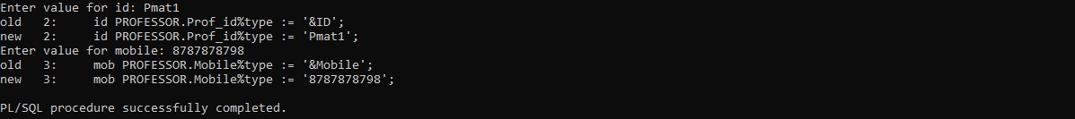
--3 Write a PL/SQL procedure to display the message as ‘Excellent’, ‘Good’, and ‘Fair’ depending on the Grade of a student in a course.
BEGIN
FOR rec IN (
SELECT s.Sname, c.Crs_name, e.Grade FROM STUDENT s
JOIN ENROLL e ON s.Reg_no = e.Reg_no
JOIN CLASS cls ON e.Cls_code = cls.Cls_code

JOIN COURSE c ON cls.Crs_code = c.Crs_code WHERE s.Reg_no = 'S17MTech002'
) LOOP
IF rec.Grade = 'S' THEN
dbms_output.put_line(rec.Sname||' '||rec.Crs_name||' Excellent'
);
ELSIF rec.Grade = 'A' THEN
dbms_output.put_line(rec.Sname||' '||rec.Crs_name||' Excellent'
);
ELSIF rec.Grade = 'B' THEN
dbms_output.put_line(rec.Sname||' '||rec.Crs_name||' Good');
ELSIF rec.Grade = 'C' THEN
dbms_output.put_line(rec.Sname||' '||rec.Crs_name||' Fair'); ELSE
dbms_output.put_line(rec.Sname||' '||rec.Crs_name||' Fair'); END IF;
END LOOP;
END;
/
--4. Write a PL/SQL procedure to print the number of ‘S’ grades that a student has obtained.
DECLARE
reg STUDENT.Reg_no%TYPE := '&Reg_no'; -- Student register number name STUDENT.Sname%TYPE;
c NUMBER(2); BEGIN
-- Retrieve the student's name SELECT Sname INTO name
FROM STUDENT
WHERE Reg_no = reg;

-- Count the number of 'S' grades SELECT COUNT(*) INTO c
FROM ENROLL e
WHERE e.Reg_no = reg AND e.Grade = 'S';

-- Output the result
dbms_output.put_line('Student ' || name || ' got S grade in ' || c || ' courses.');
END;
/

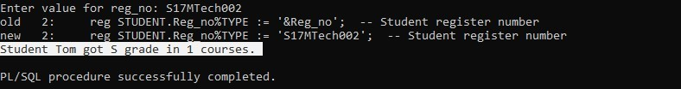
--5 Write a PL/SQL program to print the regno and student names who are studying in the first semester
BEGIN
dbms_output.put_line('Student studying in first semester (Fall 2016) are: '); FOR rec IN (
SELECT s.Reg_no, s.Sname FROM STUDENT s
JOIN ENROLL e ON s.Reg_no = e.Reg_no
JOIN CLASS cls ON e.Cls_code = cls.Cls_code
JOIN SEMESTER sem ON cls.Sem_code = sem.Sem_code WHERE sem.Year = '2016'AND sem.Term LIKE 'Fall'
) LOOP
dbms_output.put_line(rec.Reg_no||' '||rec.Sname); END LOOP;
END;
/
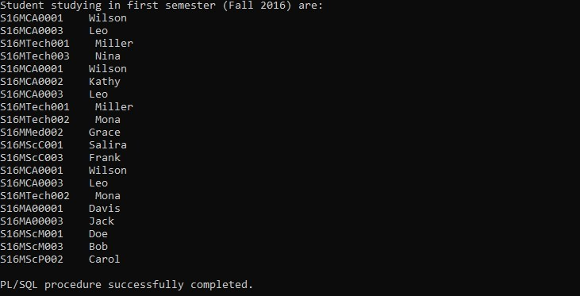
--6 Write a PL/SQL program to find out what are all the courses that a professor has handled in the semester 1 and 2.
DECLARE
PID PROFESSOR.Prof_id%TYPE; BEGIN
PID := '&pid';

dbms_output.put_line('Courses handled by '|| PID || ' in first and second semester (Fall 2016, Winter 2016) are: ');
FOR rec IN (
SELECT UNIQUE c.Crs_code, c.Crs_name FROM COURSE c
JOIN CLASS cls ON cls.Crs_code = c.Crs_code
JOIN (SELECT p1.Prof_id FROM PROFESSOR p1 WHERE p1.Prof_id = PID) p ON
p.Prof_id = cls.Prof_id
JOIN SEMESTER sem ON cls.Sem_code = sem.Sem_code
WHERE sem.Year = '2016'AND (sem.Term LIKE 'Fall' OR sem.Term LIKE 'Winter')
) LOOP
dbms_output.put_line(rec.Crs_code||' '||rec.Crs_name); END LOOP;
END;
/
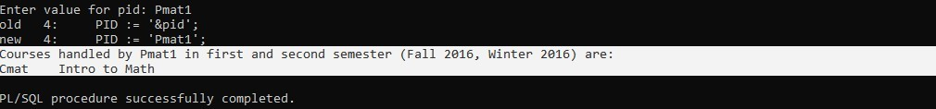
--7 Implement and test a trigger to ensure that a student cannot enroll in a course after the semester has started
CREATE OR REPLACE TRIGGER check_enrollment_date BEFORE INSERT ON ENROLL
FOR EACH ROW DECLARE
sem_start_date DATE; BEGIN
-- Get the semester start date based on the class code SELECT s.Sdate
INTO sem_start_date FROM SEMESTER s
JOIN CLASS c ON s.Sem_code = c.Sem_code WHERE c.Cls_code = :NEW.Cls_code;

-- Check if the current date is after the semester start date IF SYSDATE > sem_start_date THEN
RAISE_APPLICATION_ERROR(-20001, 'Cannot enroll in a course after the semester has started.');
END IF; END;
/

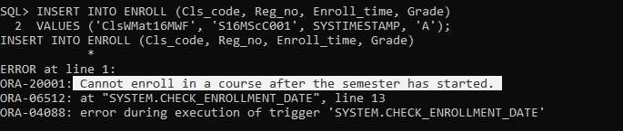
INSERT INTO ENROLL (Cls_code, Reg_no, Enroll_time, Grade) VALUES ('ClsWMat16MWF', 'S16MScC001', SYSTIMESTAMP, 'A');

--8 Implement and test a trigger to ensure that number of departments in a school cannot exceed three.
CREATE OR REPLACE TRIGGER check_department_count BEFORE INSERT OR UPDATE ON DEPARTMENT
FOR EACH ROW DECLARE
dept_count NUMBER; BEGIN
-- Count the number of departments associated with the school code in the current record
SELECT COUNT(*)
INTO dept_count FROM DEPARTMENT
WHERE SCode = :NEW.SCode;

-- If the number of departments is already 3, prevent the insertion IF dept_count >= 3 THEN
RAISE_APPLICATION_ERROR(-20003, 'Cannot add more than 3 departments to the school.');
END IF; END;
/
--10. Write a PL/SQL program to interchange the department of Professor Pmat1 and Pphy1.
DECLARE
-- Declare variables to hold the department IDs of Pmat1 and Pphy1 v_dept_pmat1 PROFESSOR.Dept_id%TYPE;
v_dept_pphy1 PROFESSOR.Dept_id%TYPE; BEGIN
-- Retrieve the current department ID of Professor Pmat1 SELECT Dept_id INTO v_dept_pmat1
FROM PROFESSOR
WHERE Prof_id = 'Pmat1';

-- Retrieve the current department ID of Professor Pphy1 SELECT Dept_id INTO v_dept_pphy1
FROM PROFESSOR
WHERE Prof_id = 'Pphy1';

-- Swap the department of Professor Pmat1 with Professor Pphy1 UPDATE PROFESSOR
SET Dept_id = v_dept_pphy1 WHERE Prof_id = 'Pmat1';

-- Swap the department of Professor Pphy1 with Professor Pmat1 UPDATE PROFESSOR
SET Dept_id = v_dept_pmat1 WHERE Prof_id = 'Pphy1';

-- Commit the changes COMMIT;

-- Output success message
dbms_output.put_line('Departments of Professors Pmat1 and Pphy1 have been interchanged.');
EXCEPTION
WHEN NO_DATA_FOUND THEN
dbms_output.put_line('One or both of the professors were not found.'); WHEN OTHERS THEN
dbms_output.put_line('An error occurred: ' || SQLERRM);
END;
/

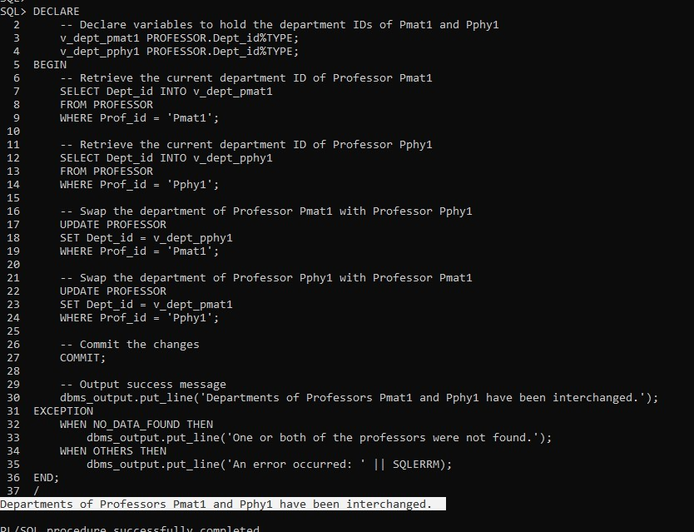
--11 Create a function that takes department ID and returns the name of the Head of the department
CREATE OR REPLACE FUNCTION get_dept_head(dept_id_in DEPARTMENT.Dept_id%TYPE) RETURN VARCHAR2
IS
v_head_name PROFESSOR.Prof_name%TYPE; BEGIN
-- Retrieve the name of the head of the department SELECT p.Prof_name
INTO v_head_name FROM PROFESSOR p
JOIN DEPARTMENT d ON p.Prof_id = d.Prof_id WHERE d.Dept_id = dept_id_in;

-- Return the name of the head of the department RETURN v_head_name;
EXCEPTION
-- Handle case when no head is found WHEN NO_DATA_FOUND THEN

RETURN 'No head found for this department';
-- Handle other unexpected errors WHEN OTHERS THEN
RETURN 'An error occurred';
END;
/
SELECT get_dept_head('Dmat1') FROM dual;
-- Output:

SELECT get_dept_head('Dphy2') FROM dual;
-- Output:
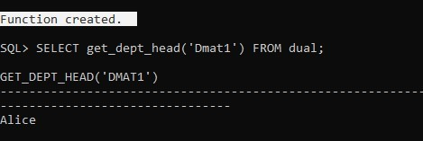
--12. Create a function that displays the age of the student from his DOB. CREATE OR REPLACE FUNCTION calculate_age(dob_in STUDENT.DoB%TYPE)
RETURN NUMBER IS
v_age NUMBER; BEGIN
-- Calculate age using the current date and DOB
v_age := TRUNC(MONTHS_BETWEEN(SYSDATE, dob_in) / 12);

RETURN v_age; EXCEPTION
-- Handle any unexpected errors WHEN OTHERS THEN
RETURN NULL; -- Return NULL if there's an error
END;
/
SELECT calculate_age(TO_DATE('2000-05-15', 'YYYY-MM-DD')) AS age FROM dual;
